`

Curiosity Rover

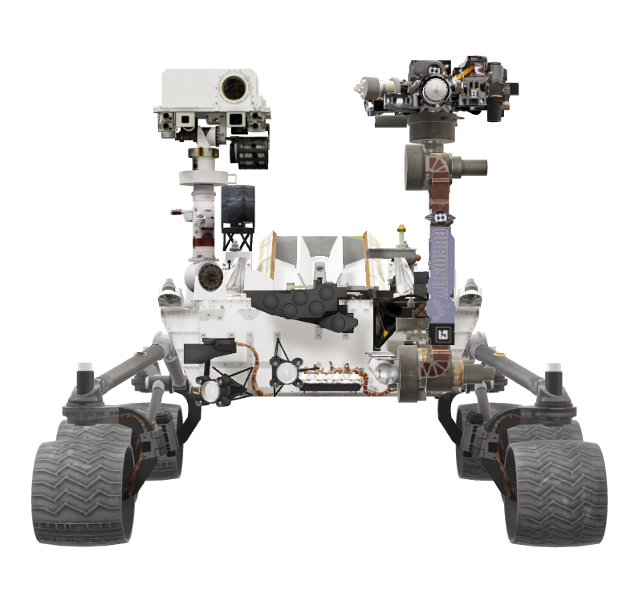

To get started right away, just tap any placeholder text (such as this) and start typing to replace it with your own. Want to insert a picture from your files or add a shape, text box, or table? You got it! On the Insert tab of the ribbon, just tap the option you need.

2011

|  |  |
| --- | --- |
| Launched in 2011 as part of NASA's Mars Science Laboratory Mission, Curiosity is the most advanced research vehicle ever sent to Mars | Curiosity’s goal on Mars is to discover if the planet has ever had the right environmental conditions to support small life forms like microbes.  Early in its mission, the Curiosity rover’s scientific instruments discovered mineral and chemical evidence to support the theory that life could persist in the harsh Martian landscape. |

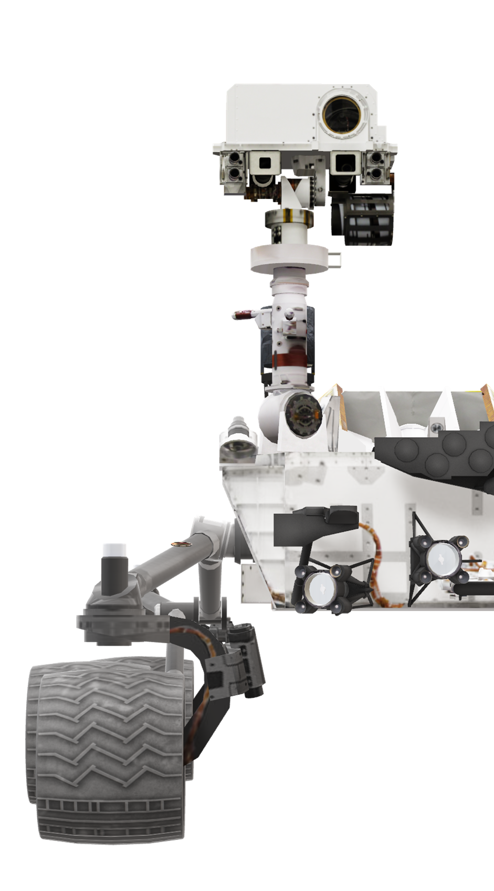

|  |  |
| --- | --- |
| Meet Curiosity  Curiosity was launched from Cape Canaveral on November 26, 2011 on the MSL spacecraft. The destination: Aeolis Palus in Gale Crater on Mars. It’s goal is to investigate the climate and geology of Mars. The data is then sent back to Earth for analysis by MSL team.  Size  The rover is about the size of a small car. It is 3 meters long (not including the arm), 2.7 meters wide and 2.2 meters tall. | |
| Arm Reach  2.2 meters  Weight  2,000 pounds  Features  Geology lab, cameras, rocker-bogie suspension, a rock-vaporizing laser, thermoelectric generator and two on-board computers |  |

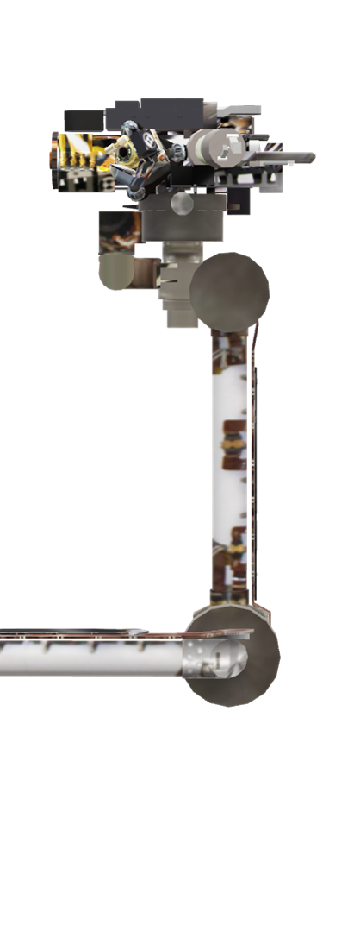

|  |  |
| --- | --- |
| Curiosity’s futuristic robotic arm |  |
|  |  |
| Curiosity’s Arm The Robotic Arm is sturdy and very maneuverable. It is used as a mount for instruments that are responsible for geological investigations.  The extendable robotic arm has 3 joints: shoulders, elbow, and wrist – just like humans do. The incredible maneuverability of the arm allows the rover to position the instruments precisely where they are needed to work. These instruments then analyze the elemental composition of the rocks and soil and take microscopic images. | CURIOSITY’S HAND Five devices are mounted on the turret structure which is located at the tip of the arm. The Mars Hand Lens Imager (MAHLI) is one of these devices, along with the Alpha Particle X-ray Spectrometer (APXS).  These two are known as in-situ or contact instruments. The other three devices on the structure are used for sample acquisition and sample preparation purposes. |

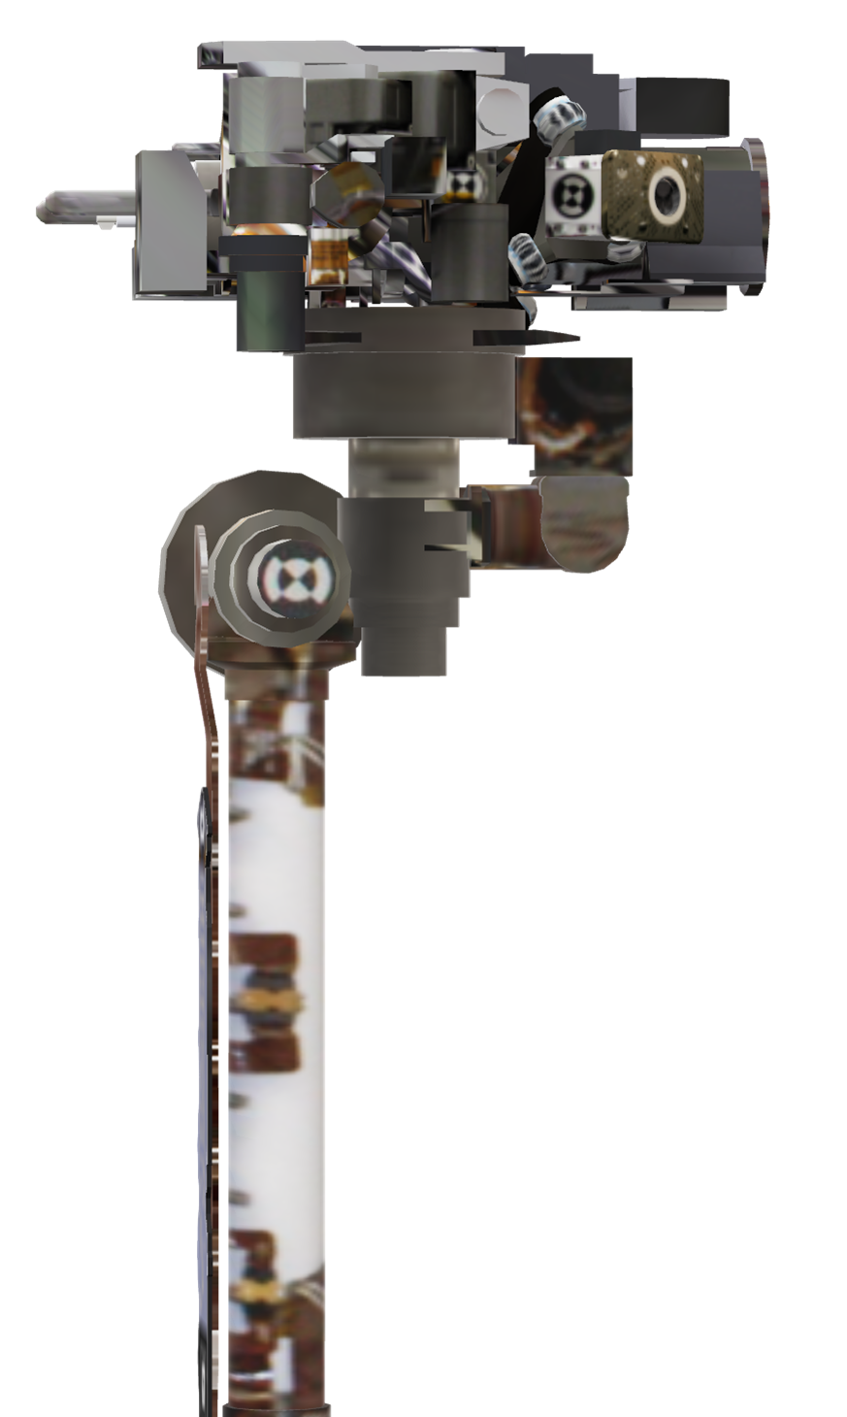

|  |  |
| --- | --- |
| MAHLIMAHLI's main mission is to help the Mars Science Laboratory research team members learn from the geological history of the Martian landscape. |  |
| Scientists are able to get up-close views of the minerals, textures, and structures in Martian rocks, as well as the surface layer of rocky debris and dust by using the Mars Hand Lens Imager, also known as “MAHLI”. The hand lens is self-focusing and takes color images of features that are as small as 12.5 micrometers (smaller than the diameter of a human hair) with a camera that is about 1.5 inches wide. The MAHLI is functional in both day and night because it carries both white light sources and ultraviolet light sources which are similar to the light from a flashlight and the light from a tanning lamp. Scientists use the ultraviolet light to induce florescence which allowed them to discover that the landscape on Mars was shaped by water by showing that there were carbonate and evaporite minerals present on the planet. | MARS HAND LENS IMAGER |

|  |  |
| --- | --- |
| CHEMCAM ChemCam is equipped with a powerful on-board laser that fires a series of pulses to vaporize the rock and soil on the Martian surface. The vapor is then analyzed to determine the elemental composition. The rover uses a spectrograph measuring the composition of the resulting plasma to read the light and provide details about the minerals in rocks. By knowing which atoms are present in the rock, the scientists are able to determine if aluminum, copper, or basalt is present. On average, the ChemCam team hopes to take up to 12 compositional readings each day for scientific analysis.  The laser also uses the laser to clear surfaces on rocks before using it’s remote camera to snap detailed images of the geological features. |  |

|  |  |  |
| --- | --- | --- |
| 3m  2.2m mm  2.7m RoverSpecifications | | MASS 8,463 pounds (3,893 kilograms) total at launch, consisting of the rover, descent / landing system and fuel. |
|  |  |
|  | | **SCIENCE PAYLOAD** Science payload: 165 pounds (75 kilograms) in 10 instruments: Alpha Particle X-ray Spectrometer, Chemistry and Camzzzera, Chemistry and Mineralogy, Dynamic Albedo of Neutrons, Mars Descent Imager, Mars Hand Lens Imager, Mast Camera, Radiation Assessment Detector, Rover Environmental Monitoring Station, and Sample Analysis at Mars |

|  |
| --- |
| The Mars Science Laboratory has six individually powered wheels. |
| rover wheel |

|  |  |
| --- | --- |
| CURIOSITY’S WHEELS Above is a model of one of the rover’s six flight wheels. It is 50 cm in diameter and 40 cm wide and the “tread” is aligned in a chevron shape to prevent wheel slip. The wheels are machined from a single block of aluminum. | CHEVRON TREAD PATTERN Curiosity temporarily gets stuck in deep sand on the surface of Mars. |